SATELLITE SYSTEMS: AN ALL-INCLUSIVE STUDY OF ARTIFICIAL SATELLITES, THEIR ORBITS AND APPLICATIONS
by
Stephen Obodai
( PUIT/24210092)
ABSTRACT
Satellites have become an essential component of modern science and technology. This project is about human-made satellites. An artificial satellite is an object, typically a spacecraft, placed into orbit around a heavenly body. Artificial satellite contributes largely to the modern transformation of this era. From global communication to scientific exploration and many more. This detailed project provides a deep dive into artificial satellite from their historical roots to sophisticated systems capable of supporting diverse applications.
This book gives a deep insight types of satellite such as Low Earth Orbit (LEO), Medium Earth Orbit (MEO), and Geostationary Earth Orbit (GEO) and how these orbital configurations influence satellite performance and functionality. It further analyzes satellite subsystems: structural, power, thermal, attitude determination and control, command and data handling, and communications highlighting their respected roles in ensuring efficient operation in the harsh space environment.
Also, the project explores the major categories of satellites we have, including remote sensing, navigation, communication, and meteorological satellites with focus on their real-world applications in our sectors such as defense, agriculture, and disaster management systems. The problem related with satellite action, particularly orbital congestion and space debris are also discussed.
Lastly this study examines upcoming trends and directions in satellite technology in the future to come. By implementing theoretical concepts with practical applications. What this project aims to provide is a clear and structured understanding of satellites and their important role in our fast and advancing modern world.
KEYWORD
Orbit, Artificial satellites, Remote sensing, Global Navigation Satellite Systems (GNSS), Space Debris, Mega constellations, Spacecraft engineering, Technology.

TABLE OF CONTENT
Contents
INTRODUCTION 7
1.1 Background of the Study 7
2.2 The Space Race and the Launch of Sputnik I 9
2.3 United States Response: Explorer I and NASA Formation 10
2.4 Evolution of Satellite Technology (1960s–1990s) 11
3. ORBITS AND SATELLITE DYNAMICS 16
3.1 INTRODUCTION 16
3.2 SATELLITE ORBITS 16
3.3 TYPES OF SATELLITE ORBITS 17
3.4 Specialized Orbits 19
3.5 Orbital Parameters 20
3.6 Launch and Injection into Orbit 20
3.7 Satellite Orbital Perturbations 21
3.8 Satellite Lifetime and Deorbiting 21
4. SATELLITE SUBSYSTEMS 22
4.2 Overview of Satellite Subsystems 22
4.3 Structural Subsystem 23
4.4 Power Subsystem (Electrical Power Subsystem – EPS) 23
4.5 Communication Subsystem 24
Thermal Control Subsystem (TCS) 25
4.7 Attitude Determination and Control Subsystem (ADCS) 27
4.8 Propulsion Subsystem 28
4.9 Telemetry, Tracking, and Command (TT&C) 28
4.11. Command and Data Handling (C&DH 30
5 TYPES OF SATELLITES 31
5.1 Communication Satellites 31
5.2 Navigation Satellites 33
5.3 Earth Observation and Remote Sensing Satellites 35
5.5 Military and Reconnaissance Satellites 38
5.6 Weather Satellites 38
5.7 Navigation and Timing Satellites 39
5.8 Space-Based Internet Satellites 40
6 CHALLENGES FACING SATELLITE TECHNOLOGY 40
6.0 Introduction 40
6.1 Technical and Engineering Challenges 41
6.2 Environmental Challenges in Space 42
6.3 Financial and Economic Challenges 45
6.4 Security and Cybersecurity Challenges 50
6.5 The Role of Satellites in Modern Transportation and Mobility 54
6.6 Satellites in Weather Forecasting and Climate Science 56

TABLE OF PICTURES
Picture 1 Sputnik 1 10
Picture 2 Explorer 1 11
Picture 3 Telstar1 12
Picture 4 Syncom 3 12
Picture 5 Weather Remote Sensing satellite activity 13
Picture 6 GPS Satellite 14
Picture 7 CUBESATS 15
Picture 8 Communication Satellites in orbit 32
Picture 9 GLONASS 34
Picture 10 Sentinel 36

TABLE OF FIGURES
Figure 1 - A cannon on top of a very high mountain shoots a cannonball horizontally. If the speed is low, the cannonball quickly falls back to Earth (A, B). At intermediate speed, it will revolve around Earth along an elliptical orbit (C, D). Beyond the escape velocity, it will leave the Earth without returning (E). 6
Figure 2 A FIGURE OF LEO, GEO AND MEO 15

INTRODUCTION

1.1 Background of the Study
A satellite or an artificial satellite is an object, typically a spacecraft, placed into the orbit around a celestial body. They have become an integral part of modern human civilization. Since the successful launch of Sputnik I on 4th October 1957, satellites have evolved from simple radio transmitters into multifunctional platforms that aids television broadcast, guide aircrafts and ships, navigation, predict weather , military operations, scientific research, and global communication. Today, satellites orbit the Earth in various altitudes, allowing us to observe the planet, connect across long distances, gather data for scientific purpose, and observe natural and human-made phenomena with increased precision.
In this global digital economy, satellites play an important role in bridging communication gaps, especially in remote areas where infrastructure such as fiber-optic networks and cellular towers is not present or insufficient. Remote sensing satellites helps in agriculture, studies in climate change, and natural resource management, while navigation satellites like GPS and Galileo aids in accurate positioning and timing services used in transportation, aviation, and military operations. Satellite technology continues to drive innovation and transformation across multiple sectors as the world is becoming more interconnected.
Despite all these advancements and achievements, challenges such as space debris, orbital congestion, high costs in launching satellites, and reliability issues still need to be handled to bring about a good space environment. Being able to understand satellites, how they work, and their applications is important in appreciating their contribution to our global digital economy.

2.HISTROY
2.1 Early Concepts and Theoretical Foundation
Before Sputnik I scientist brought about ideas that eventually formed the base for satellite technology. In the 17th century, Isaac Newton showed how orbital motion exist using his famous “cannonball thought experiment,” demonstrating that if a projectile was to be launched with sufficient speed it could potentially orbit the Earth rather than fall back to the ground. This very idea provided the first theory for understanding how man- made satellites could remain in orbit.
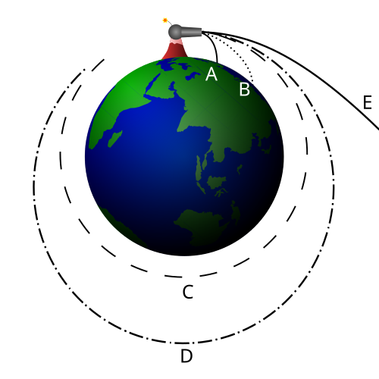
Figure 1 - A cannon on top of a very high mountain shoots a cannonball horizontally. If the speed is low, the cannonball quickly falls back to Earth (A, B). At intermediate speed, it will revolve around Earth along an elliptical orbit (C, D). Beyond the escape velocity, it will leave the Earth without returning (E).

2.2 The Space Race and the Launch of Sputnik I
In 4th October 1957, the Soviet Union launched Sputnik 1, the world’s first artificial satellite that has a polished sphere that emitted radio beeps at around 20.005 and 40.002 MHz. It contained instrument such as only two radio transmitters, batteries, and a pressure sensor. It demonstrated that intercontinental ballistic missiles could deliver nuclear missiles and shattered Western complacency (Dickson, 2001).
- It weighed approximately 83.6 kg
- It orbited Earth every 96 minutes
- It transmitted simple radio pulses
The launch of Sputnik I triggered the U.S. to accelerate its own space program and it also marked the beginning of space exploration and demonstrated that humans could place objects in orbit.
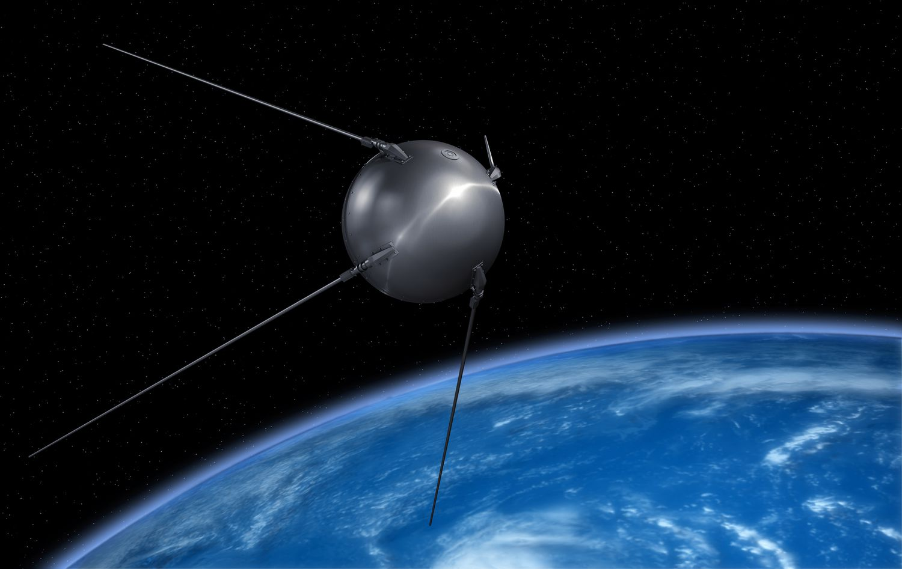
Picture 1 Sputnik 1

2.3 United States Response: Explorer I and NASA Formation
2.3.1 launch of Explorer I (1958)
In response to Russia Sputnik launches, the United States launched Explorer I on 31st January, 1958.
It was the first spacecraft to detect the Van Allen radiation belt, returning data until its batteries were exhausted after nearly four months. It remained in orbit until 1970.
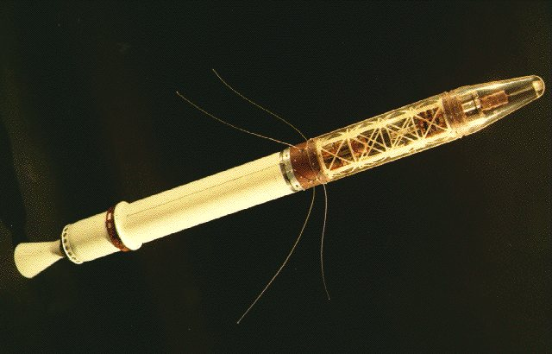
Picture 2 Explorer 1
2.3.2 Establishment of NASA
In 1958 the U.S government establish the National Aeronautics and Space Administration (NASA) to coordinate and develop space exploration initiatives. NASA became known in satellite development, launching numerous scientific and communication satellites over the following years.

2.4 Evolution of Satellite Technology (1960s–1990s)
Artificial satellite began to develop very fast during mid to late 20th century, with new ideas which lead to an upgrade in communication, weather forecasting, scientific research, and scientific research.
2.4.1 Communication satellites
Communication satellites behave as radio‑frequency transfer stations. In 1960 the first communication was introduced.
- Telstar 1 (1962): First satellite to transfer live television signals
- Syncom 3 (1964): First geostationary communication satellite.
All these satellites change the way for modern global telecommunication systems, that includes television broadcasting, telephone links connections.

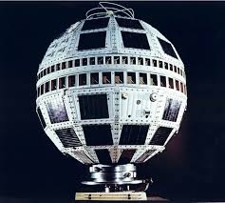
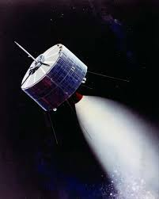
Picture 3 Telstar1
Picture 4 Syncom 3

2.4.2 Weather and remote sensing satellites
- TIROS-1 (1960): First dedicated weather satellite, allowing for cloud pattern observation from outer space.
- Landsat-1 (1972): First Earth observation satellite designed specifically for civilian land resource monitoring.
Both satellites paved a way for modern and continuous remote sensing and weather satellite.

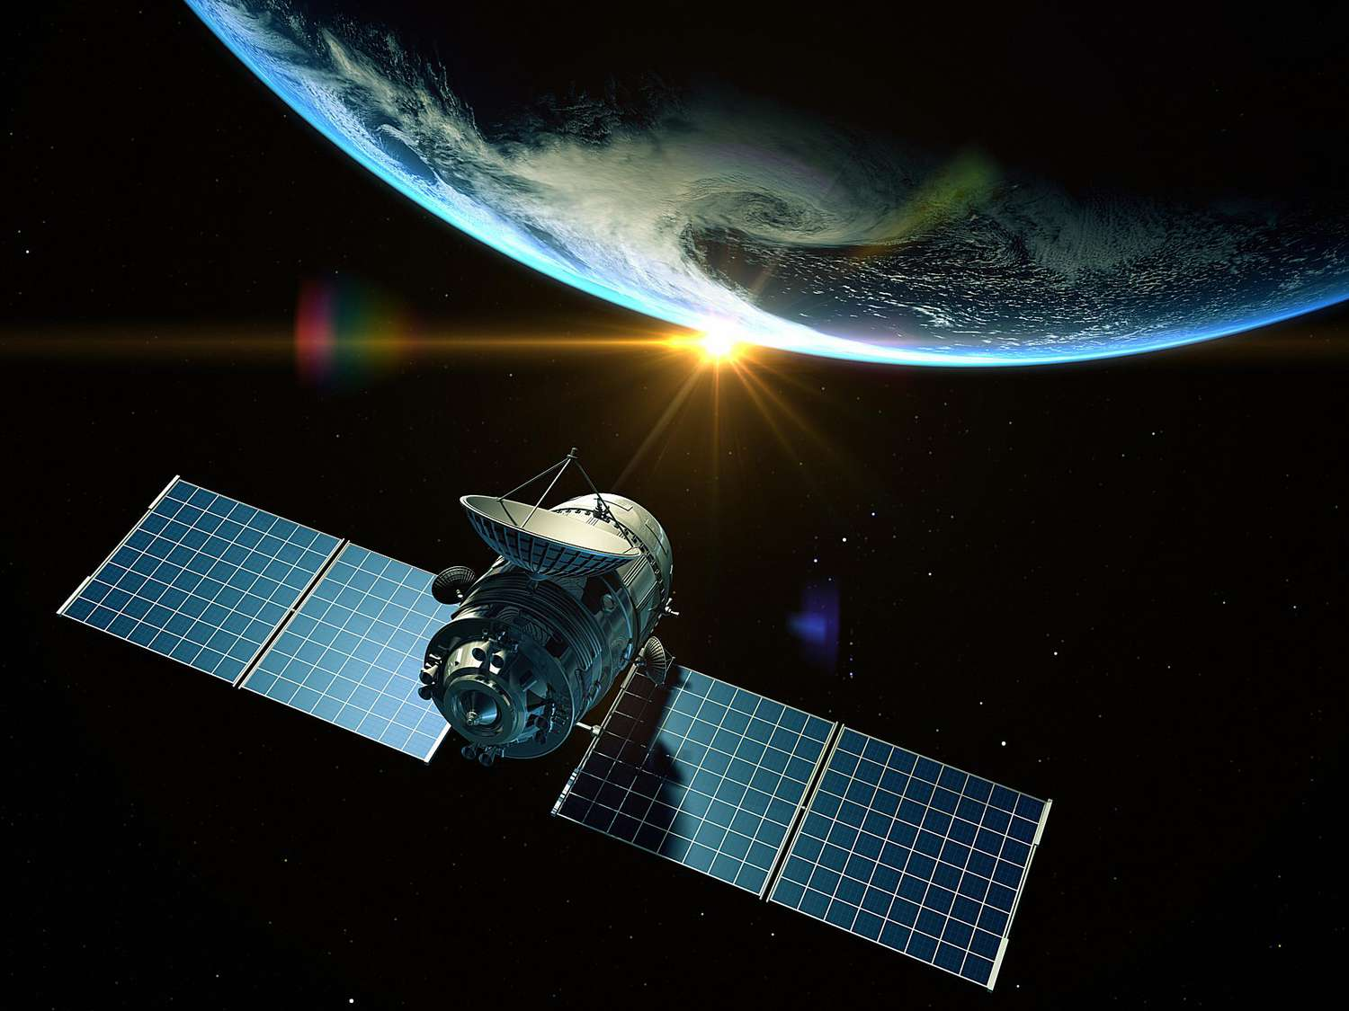
Picture 5 Weather Remote Sensing satellite activity

2.4.3 Navigation satellites
- Transit (1960s): Early navigation satellites built for US Navy
- GPS development (1970s–1990s): The U.S. decided to launch a series of satellites to provide a global navigation and timing services.
In this modern society GPS is very essential in, maritime transport, smartphones, aviation, and military operations.
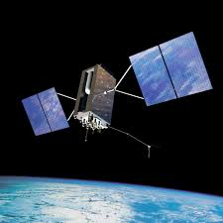
Picture 6 GPS Satellite

2.5 The Modern Satellite Era (2000s–Present)
2.6.1 CubeSats
The advancement in microelectronics allowed for CubeSats to be developed which are smaller and lightweight. These satellites are used for observation of the Earth, scientific research and for learning purpose in schools. Since they are light and small it reduced the cost of space access allowing universities, startups and smaller countries take part in space technology.
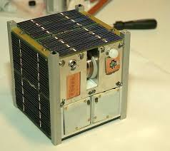
Picture 7 CUBESATS

2.6.2 Commercialization of space
Space X, Blue Origin and the rest which are private companies entered into the satellite race. They were able to launch thousands of satellites into space and introduced reusable rockets reducing cost launch.
2.6.3 Advanced Earth observation
Now with modern satellites we able to get high resolution imagery of the earth along with early disaster warning systems and real time environment data which has made decision making in the related sectors easy.

3. ORBITS AND SATELLITE DYNAMICS

3.1 INTRODUCTION
In order to understand the fundamental on how satellite function and they perform according to their specific mission in space we need to learn orbit selection and principle of satellite motion. This chapter seeks to explain the fundamentals of concept such as orbit and it types, launch process and factors influencing satellite dynamic.

3.2 SATELLITE ORBITS
A satellite orbit is path that is curved that an object follows around a celestial body. The following are principles that form the foundation of satellite orbits mechanics:
3.2.1. Newton Law of Motion
- First Law: An object in motion continues to be in motion unless acted upon by an external force.
- Second Law: Acceleration depends on mass and the force applied.
- Third Law: To every action there is an equal and opposite reaction. This is applied during satellite launch and maneuvering.
3.2.2. Gravity and Centripetal Force
Satellites can continue to remain in orbit because gravity acts as the centripetal force pulling them toward Earth. While at it their velocity prevents them from falling back to the earth surface. This balance results in continuous free-fall motion around the planet.
3.2.3 Kepler’s Laws of Planetary Motion
- Law of Ellipses: Satellites travel in elliptical orbits with Earth at onhe focus.
- Law of Equal Areas: A satellite sweeps equal areas in equal intervals of time. This makes it move faster when closer to Earth.
- Law of Periods: The square of a satellite orbital period is proportional to the cube of its average orbital radius.
All these helps us to know the orbital speed, altitude and period

3.3 TYPES OF SATELLITE ORBITS
Satellites operate in different orbits depending on their assigned mission. The main categories are as followed
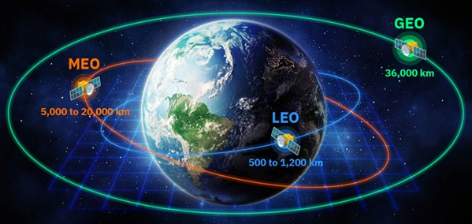
Figure 2 A FIGURE OF LEO, GEO AND MEO
3.3.1 Low Earth Orbit (LEO)
LEO is used for Earth observation because it has high spatial resolution and for human spaceflight because it stays below the inner Van Allen belt.
Altitude: 160 km – 2,000 km
Orbital Period: 90–120 minutes
Characteristic:
Short communication delay
- High-resolution imaging qualities
- Closest orbit to Earth
Applications:
- Remote sensing
- Weather satellites
- International Space Station (ISS)
- Earth Observation
- Mega constellations (Starlink)
    - Medium Earth Orbit (MEO)
MEO provides a compromise between coverage and signal strength.
Altitude: 2,000 km – 35,786 km
Orbital Period: 2 – 12 hours
Characteristic:
MEO satellites orbit at a moderate altitude while balancing coverage than LEO and less of a latency compared to GEO.
Applications:
- Navigation satellites such as GPS
- Communication satellites
Advantages:
- Wider coverage than LEO
- Stable orbits with lesser satellites needed for global coverage
    - Geostationary Orbit (GEO)
A satellite in this orbit has an orbital period equal to Earth’s rotation, appearing fixed in the sky. This is essential for television broadcast, weather satellites such as GEOS, and some communication services. Its distance causes a signal delay.
Altitude: 35,786 km
Orbital Period: 24 hours (same as Earth’s rotation)
Characteristics:
- Satellite appears to be fixed over one point on Earth
- Good for long distance communication
Applications:
- Weather monitoring
- Military communication
- Telecommunications
- Broadcasting TV
Advantages:
- Very wide field of view
- Constant coverage of specific regions

3.4 Specialized Orbits
A specialized orbit is a specific path a satellite takes that is chosen for a specific job.
3.4.1 Sun-Synchronous Orbit (SSO)
This is a special type of LEO that passes over the same part of Earth at the same solar time daily.
Applications:
- Used for monitoring climate
- Environmental observation
- Used in mapping in high resolution
3.4.2 Polar Orbit
This orbit travels over the Earth’s poles which covers the entire planet over multiple passes.
Application
- Earth observation
- Reconnaissance
- Weather Satellites

3.5 Orbital Parameters
Satellite placement can be described using six classical orbital elements. These parameters allow engineers to track and predict satellite location precisely.
They are as followed:
- Right Ascension of the Ascending Node (RAAN)
- Argument of Perigee
- True Anomaly
- Semi major axis
- Eccentricity
- Inclination

3.6 Launch and Injection into Orbit
3.6.1 Launch Vehicles
Rockets that carry satellites into space must be able to withstand Earth’s gravity. Examples of modern launch vehicles are Falcon 9, Ariane 5 and Long March.
3.6.2 Staging
Rockets use multiple stages to reduce weight and increase the rocket efficiency.
3.6.3 Orbital Insertion
After the satellites reaches space, it is released and then it performs maneuvers using thrusters to go to its final destination.
3.6.4 Transfer Orbits
These help satellites move from the launch site into their assigned orbit. The transfer paths are as followed:
- Hohmann Transfer Orbit (HTO)
- Geostationary Transfer Orbit (GTO)

3.7 Satellite Orbital Perturbations
An orbit cannot be perfectly stable. Lot of forces disturb a satellites motion in space
- Atmospheric Drag - Affects LEO satellites
- Earth’s Roundness - Earth is not a perfect sphere which causes orbital shifts.
- Sun and Moon Gravity - Tidal forces alter satellite inclination.
- Solar Radiation Pressure - Photons from the Sun exert small forces that alter the orbit.
To maintain orbital stability, satellites use propulsion and thrust to perform station-keeping maneuvers.

3.8 Satellite Lifetime and Deorbiting
3.8.1 Operational Lifetime
Satellites use last between 5–20 years, depending on its fuel, design, and environment.
3.8.2 End-of-life disposal
To reduce space debris, satellites are disposed through:
- Controlled atmospheric re-entry which takes place in LEO
- Transfer to graveyard orbits which takes part in GEO
- Natural decay
International guidelines are enforced to ensure responsible disposal practices to protect the orbital environment.

4. SATELLITE SUBSYSTEMS
4.1 Introduction
A satellite is a complex engineering system consisting of several subsystems that works together to ensure proper operation and mission success. Every subsystem performs a special function, but they operate interdependently to help with communication, remote sensing, weather forecasting, scientific research, or other specialized missions.

4.2 Overview of Satellite Subsystems
Each subsystem ensures the satellite functions perfectly in the harsh environment of space
The major subsystems include:
- Structure Subsystem
- Electrical Power Subsystem
- Communication Subsystem
- Thermal Control Subsystem
- Attitude Determination and Control Subsystem
- Propulsion Subsystem
- Telemetry, Tracking, and Command
- Payload Subsystem
- Onboard Data Handling and Computer Subsystem
.

4.3 Structural Subsystem
4.3.1 Description
The structure subsystem provides the physical frame and mechanical support of the satellite during launch. It ensures it protects all other subsystems during launch, deployment, and orbital operations.
4.3.2 Functions
- Able to withstand mechanical stress during launch
- Ensure mechanical stability in orbit
- Support the payload and its internal components
- Has mounting points for solar panels, antennas, thrusters, and others
4.3.3 Materials Used
Materials used must be able to offer strength, low weight, and resistance to temperature variations. Satellite structures are typically made of:
- Aluminum alloys
- Titanium
- Carbon-fiber composites
- Honeycomb panels

4.4 Power Subsystem (Electrical Power Subsystem – EPS)
4.4.1 Overview
The EPS supplies electrical energy to all onboard equipment and also generates, stores and condition power to all satellite’s component. Due to the fact satellites operate far from direct human intervention, reliable power generation and storage are critical in these areas.
4.4.2 Sources of Power
- Solar panels or arrays: Convert sunlight into electrical energy. They are arranged in strings and are mounted on solid panels that gets deployed after launch.
- Batteries: Store energy for use during eclipses or high-power operations where power is drawn from rechargeable lithium batteries.
- Radioisotope Thermoelectric Generators (RTGs): Used in deep-space missions
- Power conditioning and distribution unit (PCDU): Regulates voltage and protects against short circuits where it switches power to different buses.
4.4.3 Power Regulation Components
- Power regulation modules
- Charge controllers
- Distribution units
4.4.4 Functions
- Generate and store electrical energy
- Supply power to all satellite subsystems
- Regulate voltage and current

4.5 Communication Subsystem
    - Purpose
The communication subsystem ensures information is transferred between the satellite and ground control stations. For communication satellites, this subsystem also forms part of the mission payload. It transmits:
- Telemetry: Housekeeping data which includes temperatures and voltages.

- Payload data: High‑speed downlinks for communication traffic.
- Command: Uplink of instructions and software patches.
- Tracking: Ranging tones to determine orbit.
4.5.2 Components
- Antennas such as high-gain, low-gain and phased-array
- Transponders and receivers
- Radio frequency (RF) amplifiers
- Modulators and demodulators
4.5.3 Functions
- Receive commands from ground stations
- Transmit remote sensing data to Earth
- Relay communication signals (especially for telecom satellites)
- Support high-speed data transmission and encryption

Thermal Control Subsystem (TCS)
4.6.1. Purpose
Space is a vacuum so heat can only be transferred by radiation. These causes surface temperatures to swing very low in eclipse and very high in direct sun. The TCS manages this through passive and active methods.
4.6.2 Importance
Space is characterized by extreme temperature changes. Satellites may experience temperatures ranging between −150°C to +150°C depending on solar exposure. The TCS keeps onboard equipment within safe operating limits.
4.6.2 Components
Passive systems:
- Thermal coatings
- Insulation blankets (MLI – Multi-Layer Insulation)
- Heat pipes
- Radiators
Active systems:
- Heaters
- Thermostats
- Pumped fluid loops (rare in small satellites)
4.6.3 Functions
- Protect sensitive components from overheating or freezing
- Maintain optimal operating environment
- Regulate internal temperature

4.7 Attitude Determination and Control Subsystem (ADCS)
4.7.1 Definition

ADCS makes sure that the satellite maintains the correct alignment in space. For example communication satellites must keep antennas pointed toward Earth and imaging satellites(payloads) must point cameras toward targeted location.
4.7.2 Attitude Determination Sensors
- Earth sensors
- Magnetometers
- Gyroscopes
- Star trackers
- Sun sensors
4.7.3 Attitude Control Actuators
- Reaction wheels
- Momentum wheels
- Thrusters
4.7.4 Functions
- Maintain antenna alignment
- Control satellites spin and rotation
- Stabilize satellite orientation
- Point payload instruments

4.8 Propulsion Subsystem
4.8.1 Purpose
The propulsion subsystem ensure it provides the necessary force to maneuver the satellite in space to it requires destination in orbit. Not all satellites have propulsion, but for those in GEO and deep space missions or requiring station keeping rely on it heavily.
4.8.2 Functions
- Collision avoidance
- Deorbiting
- Orbit insertion
- Orbit raising
- Station-keeping

4.8.3 Types of Propulsion
- Chemical propulsion: Uses liquid or solid propellants
- Electric propulsion: Includes ion thrusters or Hall-effect thrusters
- Cold gas systems for small maneuvers

4.9 Telemetry, Tracking, and Command (TT&C)
4.9.1 Component Includes
- Telemetry transmitters
- Command receivers
- Ground station interfaces
4.9.2 Functions
- Telemetry: Sends health and status data of the satellite
- Tracking: Determines the satellite’s position and its trajectory
- Command: Receives operational instructions from Earth
4.10 Payload Subsystem
4.10.1 Overview
The payload subsystem shows the primary mission of the satellite. It varies depending on the satellite’s purpose and built.
4.10.2 Examples of Payloads
- Scientific instruments
- Navigation signal generators
- Meteorological sensors
- Communication antennas and transponders
- Cameras for Earth observation
- Radar sensors
4.10.3 Functions
- Perform mission according to specific task
- Collect and transmit mission data to earth
- Enable communication services
- Enable navigation services

4.11. Command and Data Handling (C&DH

4.11.1 Purpose
The C&DH subsystem is the brain of the satellites. It consists of:
- On-board computer (OBC): The OBC processes telecommands from the ground station which executes stored sequences, and monitors the health of all subsystems.
- Data Storage: Solid-state recorders such as flash buffer payload data until a ground-station pass. Modern satellites generate hundreds of Gbits per day.
- Data buses: Ethernet and some others are used to interconnect subsystems. The bus must be robust to single-event.

4.11.2 Components
- Data buses
- Software and operating systems
- Central onboard computer
- Memory units
4.11.3 Functions
- Execute autonomous operations
- Handle error detection and recovery
- Control subsystem operations
- Manage payload data
- Store and process instrument

4.12 Integration of Satellite Subsystems

While each subsystem has a specific function, they must work together seamlessly. For instance:
- ADCS ensures accurate pointing for payloads and communication.
- TT&C enables monitoring of all subsystems via telemetry.
- The power subsystem powers the communication, thermal, and computer systems.
- The structure holds solar panels, antennas, and sensors.
Subsystem integration is essential for mission reliability and performance.

5 TYPES OF SATELLITES
Satellites can be classified based on their function, design, mission objectives, and the orbital paths they occupy. Satellites have evolved into systems that is tailored to address specific humanity global needs such as communication, navigation, resource monitoring, scientific research, and defense.

5.1 Communication Satellites
Communication satellites are simply relay station in space that sends signals between distant locations on Earth. They can be found in the Geostationary Orbit (GEO). The satellite does not make a signal it just passes it along.

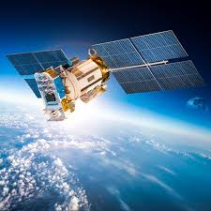
Picture 8 Communication Satellites in orbit

Functions
- Broadcasting television and radio.
- Change frequency
- Enabling international telephone communication.
- Connect remote areas
- Supporting broadband internet services.
- Facilitating secure military communications.
Examples
- Commercial broadcasting satellites used by media corporations.
- Intercontinental communication satellites supporting global telecom networks.
Importance
Communication satellites allow people anywhere on Earth weather on mountain top, at sea or war zone stay connected where cable and cell towers can not reach.

5.2 Navigation Satellites
Navigation satellites help in positioning, timing, and navigation services. They are essential for transportation and mapping. They fly around the Earth where they constantly send out signals. They work when your phone or GPS device listen to four or more of these satellites at once. Where it compares the tiny difference in how long each signal took to arrive it then figures out your exact location down to a few meters without even internet service.

Picture 9 GLONASS

Functions
- Determining accurate geographic location
- Supporting aviation, maritime, and land navigation.
- Enabling precision agriculture.
- Synchronizing communication networks and financial systems.
- Synchronize clocks worldwide
Examples
- Global Positioning System (GPS)
- GLONASS
- Galileo
- BeiDou
Importance
Navigation satellites have become a backbone in our daily life, enabling GPS-enabled devices, location-based applications, and efficient global transportation. Most people would not notice them until they stop working.

5.3 Earth Observation and Remote Sensing Satellites
These satellites take detailed information about Earth’s surface, atmosphere, and oceans. They are deployed in Low Earth Orbit (LEO) for high-resolution imaging. They can see things most human eyes cannot see such as heat, moisture, soil and pollution levels.
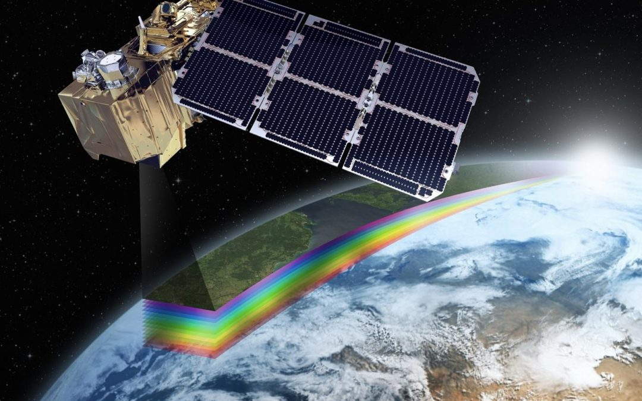
Picture 10 Sentinel
Functions
- Weather forecasting and climate monitoring
- Agricultural and crop prediction
- Environmental and disaster management
- Resource mapping and land use analysis
- Track changes over time
Examples
- Landsat
- Sentinel
- Radarsat
- And other imaging satellites used for environmental conservation
Importance
Earth observation satellites provide critical data for sustainable development, scientific research, and early warning detection systems for natural disasters. Earth Observation satellites are like the planet eyes in space.

5.4 Scientific Satellites
Scientific satellites are used for exploration and research beyond Earth. They capture data that helps scientists study space phenomena and fundamental physical laws. Some are close to the Earth while others drift way out to special spot were sunlight and gravity balance nicely.
Functions
- Observing planets, stars, and the galaxies
- Investigating cosmic radiation and magnetic fields
- Conducting experiments
- Exploring deep within space objects
Examples
- Space telescopes used for astronomical studies such as Hubble Space Telescope and James Webb Space Telescope
- Probes studying planetary systems such as Kepler
Importance
These satellites expand human knowledge of the universe, contributing to scientific knowledge and inspiring technological advancement. These is because the answers to the biggest question are not found on the ground.

5.5 Military and Reconnaissance Satellites
Military satellites assist in national security, surveillance, and intelligence-gathering operations which ensures our safety. Regular satellites like Landsat are for farming and agriculture where as military satellites are much sharper, are updated more often and images taken are kept from the public.
Functions
- Monitoring missile launches and spot troop movements
- Conducting secure defense communications
- Enabling battlefield surveillance and targeting
- Detecting and monitoring nuclear activity
- Tracks ships and submarines
Examples
- High quality reconnaissance satellites such as Hexagon(retired)
- Defense communication networks such as Satellite Data System (SDS)
Importance
These satellites contribute greatly to national defense capabilities and contribute to global security through intelligence and early warning detection systems.

5.6 Weather Satellites
Weather satellites collect atmospheric data which is used for forecasting and climate studies. They carry special cameras and sensors that see clouds, water vapor, rain intensity and sea temperature. They operate in both LEO and GEO, depending on their mission requirements.
Functions
- Monitoring cloud patterns, storms, and hurricanes.
- Analyzing temperature wind speed
- Predicting climate changes and extreme weather events before they happen
Examples
- Weather monitoring satellites used by global meteorological sector such as GEOS, Meteosat, JPSS, INSAT and Fengyun
Importance
Weather satellites play a vital role in saving lives, managing disasters, and supporting agriculture, predicting natural disasters and aviation.

5.7 Navigation and Timing Satellites
Some satellites are specifically built for precise timing services. Thes satellites usually takes 12 hours to circle the Earth.
Functions
- Synchronizing global financial systems.
- Power grid stability.
- High-precision scientific measurements.
Importance
Navigation satellites are the reason your phone knows where you are, the bank is able to know when you get paid and the power does not go out when everyone turns on their AC at the same time.

5.8 Space-Based Internet Satellites
These satellites form large constellations in LEO to provide global broadband internet. One big example is Starlink which is almost available in every country.
Features
- Less latency in communication.
- Thousands of interconnected satellites working as a network.
- Expanding internet access to remote areas.
Importance
These systems support education, remote work, business, and emergency communication in underserved regions or ongoing war countries.

6 CHALLENGES FACING SATELLITE TECHNOLOGY

6.0 Introduction
Satellites have become building bricks to modern communication, navigation, scientific research, and environmental monitoring and the more advance we become at it we are faced with a growing number of complex challenges. These challenges do not only affect performance and reliability of satellites but also their long-term sustainability in orbit. Whiles nations and private companies continue to launch increasing numbers of satellites into space, the environment becomes more crowded ad competitive.
Satellite challenges can be grouped into several categories:
- Technical limitations
- Environmental hazards
- Difficulties in operating
- Security threats
- Regulatory issues.

6.1 Technical and Engineering Challenges
Even with technological advancement, satellites remain some of the most difficult machines to be built. Its complex design and construction require very precise engineering because once launched satellite, physical repairs cannot be made. We look at key technical challenges that limit satellite performance and reliability.

6.1.1 Shrinking Limits
With the growing demand for smaller, less and heavy, and cheaper satellites especially smallsats and CubeSats downsizing has limits. As the components being used become smaller, engineers find it difficult to maintain durability, heat removal, efficient antenna performance, and power capacity. Smaller satellites tend to not carry large antennas, powerful batteries, or even advanced sensors, which reduces their capability compared to larger satellites.
6.1.2 Power Limitations
Satellites depend heavily and always on solar panels and onboard batteries, but power generation is still a problem. Solar panels can degrade in space due to radiation. Whiles batteries lose efficiency over time due to repeated charging cycles. For satellites that uses high power instruments like radars, imaging sensors, or communication payloads lack of sufficient power can severely limit mission performance.
6.1.3 Radiation Damage
Space is filled with a lot of harmful radiation like in the Van Allen belts. High energy particles can damage electronic circuits, affect signals, degrade solar panels, and shorten the lifespan of satellites. Engineers use shielding and radiation proof components but it make satellites heavier and more expensive.
6.1.5 Aging and Wear of Components
Satellites naturally degrade over time even with quality engineering involved in building them. Mechanical parts like reaction wheels, gyroscopes, and moving antennas wear out. Batteries lose their ability to charge, and software may become outdated or incompatible with newer systems on Earth. Because maintenance is impossible once a satellite is launched, engineers must design systems with long term reliability in mind which is a difficult and costly process.

6.2 Environmental Challenges in Space
Satellites also face harsh and unpredictable conditions in space. Unlike Earth space is filled with natural and human made hazards that can damage a satellite. As more countries and private companies join the space race, environmental challenges continue to grow rapidly.
6.2.1 Space Debris and Orbital Junk
Space debris refers to unfunctional satellites, spent rocket stages, metal fragments from collisions and even tools accidentally left behind by astronauts. These objects may be small but they travel at speeds of up to 28,000 kilometers per hour making them dangerous. Even tiny object the size of a bolt can damage a satellite or its solar panels. Large debris can completely destroy an active satellite on hitting it. The more objects that accumulate in orbit, the higher the risk of collisions. This threat has attracted international attention and led to growing calls for debris mitigation method.

6.2.2 Natural Space Particles
Also man-made debris, satellites also face natural hazards. These are tiny particles of rock or metal that comes from comets or asteroids. Even though they are small, they travel at extremely high speed and strike satellites with intense force. They are unpredictable and difficult to track. Even thick shielding cannot ensure full protection. When they strike a satellite, they may cause dents, cracks, or tiny holes that allow heat to escape. With time, repeated impacts can weaken structural components, making satellites more vulnerable to failure.

6.2.3 Solar Radiation and Space Weather
Space weather are conditions caused by solar activity, such as solar flares and radiation storms. These events release high energy particles that can interfere with satellite electronics, causing errors, signal disturbances, or complete shutdowns.
Radiation storms can also destroy onboard computer systems, degrade solar panel efficiency, interfere communication signals and interfere with GPS accuracy.
In serious cases solar storms have the potential to destroy unprotected satellites. Space weather prediction is still a developing science. While monitoring has improved, engineers cannot fully shield satellites from powerful solar events without causing significantly increase in weight and cost.

6.2.4 Atmospheric Drag (for Low Earth Orbit Satellites)
Satellites operating in Low Earth Orbit (LEO) face environmental challenge known as atmospheric drag. Even though space is often described as a vacuum, trace amounts of atmospheric gases exist up to hundreds of kilometers above Earth’s surface.
This result in Satellites slow down gradually, Orbits decay over time and More fuel is required to maintain altitude
Satellites without enough fuel will re-enter Earth’s atmosphere and burn up. Events such as increased solar activity can temporarily expand the upper atmosphere, causing a sudden increase in drag. This complicates mission planning and shortens satellite lifespan.
6.2.5 Harsh Thermal Conditions
Space has extreme temperature differences. When a satellite faces the Sun, temperatures can rise up. When it passes into Earth’s shadow, temperatures drop very low. These rapid thermal shifts can cause things like Expansion and contraction of materials in metals especially, Exhaustion in metal components, Changes in antenna shape or alignment and Reduced efficiency of batteries and sensors
Thermal control systems help manage heat, but they are not perfect. If they malfunction, the satellite may overheat or freeze leading to serious performance issues.

6.2.6 Orbital Congestion
As satellite launches increase certain orbits start to become overcrowded especially in Low Earth Orbit and Geostationary Orbit. Companies building satellite contribute to congestion by deploying hundreds or thousands of satellites.
Effect of Orbital congestion
- Collision risks
- Interference between satellite signals
- Difficulty in maneuvering satellites to avoid space debris
- Competition for limited orbital space in the LEO
This challenge is partly environmental and regulatory, as organizations must coordinate with one another to share space safely. Without proper management, the orbital environment could become dangerously choked.

6.2.7 Unpredictable Space Environment
Many aspects of space cannot be accurately predicted. Variations in radiation levels, density, solar wind, and gravitational forces create uncertainties that make satellite operations risky. Even small miscalculation can affect a satellite’s orientation or orbital path. Engineers must design satellites with enough flexibility to adapt to unexpected and unknown conditions.

6.2.8 End-of-Life Disposal Challenges
When satellite reaches the end of its operational lifespan, it becomes potential debris. Proper disposal requires the following Moving it to a graveyard orbit like GEO, De-orbiting it safely, ensuring remaining fuel does not explode and preventing the satellite from drifting uncontrolled.
However, lot of older satellites were not designed with disposal systems in mind. Rerouting them is impossible, and replacing them is costly. As a result end of life management is becoming a major environmental challenge for the space industry.

6.3 Financial and Economic Challenges
Satellites are part of the most expensive technological systems ever built. Even the smallest satellite missions involve lot of financial planning, high risk investment, and tough economic decision making. As the demand for satellites increases, so too does the financial pressure on governments, private companies, and research institutions. This section examines the major financial and economic challenges that affect satellite design, launch, operation, and long-term sustainability.

6.3.1 High Development and Manufacturing Costs
The process of designing and manufacturing a satellite requires specialized knowledge, advanced materials, and good engineering. Every component must be thoroughly tested to make sure it can withstand the harsh environment of space. These tests include vibration tests, thermal vacuum tests, radiation exposure test, and electrical assessments. Failure at any of the mentioned stage can lead high redesigns cost or complete project delays.
Large communication satellites can take years to develop and cost hundreds of millions of dollars. Even smaller satellites, such as CubeSats, can become expensive when advanced instruments, or custom components are required.
Another factor contributing to the high cost is the need for radiation hardened electronics. These parts are more expensive than regular electronic components because they must be specially manufactured to withstand the effects of radiation in space. As a result building just one satellite is a major investment that requires careful planning and budgeting with little or no room for mistake.

6.3.2 High Cost of Launch Services
Launch costs is one of the biggest financial barriers in satellite missions. Placing a satellite into orbit requires a powerful rocket, extensive ground support, and carefully timed launch conditions. Even with new reusable rocket technologies, launch prices remain high due to (Strict safety requirements, High cost of rocket fuel, Maintenance of launch facilities, Insurance and liability coverage and Fees related to launch licenses and tracking )
Traditional launch providers could charge tens or even hundreds of millions of dollars for a single mission. Although newer companies have introduced more affordable options, the cost of launch services still consumes a significant percentage of a satellite project’s budget.
6.3.3 Cost of Satellite Operation and Maintenance
Once a satellite is successfully in orbit, operational expenses continue throughout its lifetime. Ground control stations are (Monitor the satellite’s position, ensure communication links remain stable, Upload software updates, perform orbit adjustments and Track and respond to anomalies)
Staffing, electricity, data storage, and ongoing technical support all contribute to operational costs. For communication or Earth observation satellites, additional costs arise from processing and analyzing large amounts of data.
Also, satellites require fuel for orbit maintenance, especially those in Low Earth Orbit. As fuel levels drop, operational flexibility decreases. Running out of fuel means the mission may end prematurely, resulting in financial losses.

6.3.4 Insurance and Risk Management Costs
Satellite missions are inherently risky. A single failure—either during launch or in orbit—can result in losses worth hundreds of millions of dollars. To protect against such losses, organizations purchase insurance coverage for both launch and in-orbit operations.
Insurance costs are influenced by:
- Satellite design complexity
- Reliability of the launch vehicle
- Satellite’s intended orbit
- Historical performance of similar missions
- Expected mission duration
Insurance premiums can range from 5% to 20% of the satellite’s value. For large commercial satellite operators, this represents a significant ongoing expense. If an insurer judges that a mission has high risks, they may refuse coverage altogether, forcing companies to accept the risk themselves.
In cases where a satellite is damaged but not completely destroyed, insurance claims can become complicated and lengthy, creating financial uncertainty for operators.

6.3.5 Funding Challenges for Government and Academic Satellites
Governments often finance satellites for national security, communication, weather forecasting, and scientific research. However, public budgets are limited, and satellite programs must compete with other national priorities such as education, healthcare, and infrastructure.
Academic institutions face even greater challenges. University-led missions depend on grants, sponsorships, and partnerships. Although small satellites like CubeSats have become popular in educational settings, funding limitations often restrict the quality of instruments and the scale of missions.
Because of inconsistent or insufficient funding, many promising satellite projects remain unrealized or experience long delays. This problem is more severe in developing countries where space programs are still emerging.

6.3.6 Market Competition and Commercial Pressure
The global space industry has become highly competitive, with numerous companies entering the satellite market. While this competition has led to innovation and lower launch costs, it has also created new economic challenges. Companies must constantly update their technology to remain competitive, which increases research and development expenses.
In the field of satellite internet services, mega-constellations require thousands of satellites, involving tremendous upfront investment. Companies must manufacture satellites quickly, launch them frequently, and replace them often due to short lifespans in LEO. If the business model fails to attract enough customers, investors may face significant financial losses.
In the Earth observation market, competition drives down prices for satellite imagery, making it harder for smaller companies to survive. This economic pressure can lead to consolidation, with a few dominant players controlling the market.

6.3.7 Economic Impact of Satellite Failures
Satellite failures whether during launch or in orbit have severe financial consequences. A launch failure can destroy years of work and millions of dollars of investment. Even minor malfunctions can lead to reduced performance, shortened mission lifetime, or complete mission loss.
Beyond direct financial losses, satellite failures can also:
- Damage a company’s reputation
- Lead to loss of customers
- Interrupt essential services (e.g., weather forecasting, communication, GPS)
- Cause delays in future missions
Failures also demand lengthy investigations to understand what went wrong, increasing costs further.

6.4 Security and Cybersecurity Challenges
As satellites become more deeply integrated into global communications, navigation, weather forecasting, financial transactions, and military operations, security threats are becoming a major concern. While early satellites were relatively isolated and difficult to access, modern satellite systems often communicate using digital networks and internet-based ground stations, making them more vulnerable to cyberattacks. Additionally, geopolitical tensions and the militarization of space have introduced new risks that were not present in the early decades of space exploration.
The security challenges facing satellite technology can be divided into two broad categories: cybersecurity threats and physical or military threats. Both types pose serious risks to the safety, reliability, and long-term functionality of satellites. This section discusses these challenges in detail.

6.4.1 Vulnerability to Hacking and Unauthorized Access
One of the most significant cybersecurity threats is the possibility of hackers gaining unauthorized access to satellite systems. While satellites orbit far above Earth, their communication signals can be intercepted from the ground by anyone with the proper equipment. Hackers may attempt to interfere with the control signals, manipulate software, or disrupt data transmission.
There are several ways unauthorized access could threaten satellite missions:
Firstly, taking control of the satellite. A skilled attacker could attempt to send commands to alter the satellite’s orbit or orientation, potentially causing collisions or loss of mission. Shutting down communication systems.
Secondly, Disabling the satellite’s transponders would make it impossible to receive or transmit signals.
Thirdly, Corrupting data. Satellites used for weather forecasting, military intelligence, or navigation could send incorrect information, leading to real-world consequences.
Lastly, Monitoring secure channels. Hackers could intercept sensitive or classified communications transmitted through satellites.
The growing reliance on commercial software and internet-based connections increases the number of possible entry points for cyberattacks. As more companies and governments use satellites for critical infrastructure, the stakes continue to rise.

6.4.2 Signal Jamming
Signal jamming occurs when someone transmits a stronger signal on the same frequency as a satellite, disrupting communication between the satellite and its ground station. Jamming can be intentional (malicious) or unintentional (accidental interference from other radio sources). Regardless of the source, the consequences can be severe.
Examples of disruptions caused by jamming include:
Loss of television or radio broadcast signals, Interference with GPS navigation accuracy, Disturbance of military communication channels, Failure in emergency response communication systems
GPS satellites are especially vulnerable because their signals are very weak by the time they reach Earth. Even a small portable jammer can disrupt GPS services across a large area. Terrorist groups, smugglers, and even truck drivers have used jammers to hide their location, unintentionally interfering with aviation or maritime navigation.
As jamming devices become cheaper and more available, the challenge grows.

6.4.3 Spoofing of Satellite Signals
Spoofing is a more sophisticated threat than jamming. Instead of blocking the signal, spoofing involves sending fake satellite signals that appear authentic. For navigation satellites like GPS, spoofing can mislead receivers into believing they are in a different location.
This has dangerous real-world consequences:
Ships or aircraft could be misdirected, Military drones could be forced off course, financial networks that rely on GPS timestamps could experience errors, Critical infrastructure systems could malfunction.
6.4.4 Militarization and Anti-Satellite Weapons
Satellites are now considered strategic assets by many nations. This has led to the development of anti-satellite (ASAT) weapons, which are designed to disable or destroy satellites during conflict. ASAT weapons are as followed:
Missiles launched from Earth to physically hit a satellite, Co-orbital satellites that approach and damage another satellite, Laser systems that blind or damage optical sensors, Electronic warfare systems that disrupt communications
The use of ASAT weapons is extremely dangerous because destroying a satellite can create thousands of pieces of debris, threatening other satellites in orbit. Several ASAT tests conducted by different countries have contributed to growing concerns about the weaponization of space.
The increasing presence of military satellites and surveillance systems also creates tension between nations, raising the possibility of conflict extending into space.

6.4.5 Weaknesses in Ground Stations
While satellites themselves are difficult to physically access, their ground control stations are located on Earth and are therefore more vulnerable. Ground stations can face:
Physical attacks or sabotage, Power outages or infrastructure failures , Cyberattacks on computer networks, Insider threats from employees and Natural disasters such as floods or earthquakes

6.4.6 Software Vulnerabilities and Outdated Systems
Many satellites remain operational for 10–15 years, and some even longer. Over time, the software they rely on becomes outdated, making it easier for attackers to exploit vulnerabilities. Updating satellite software is challenging because it must be done remotely and carefully tested to avoid disrupting operations.
Older satellites may also use outdated encryption protocols that are no longer secure by modern standards. This creates opportunities for attackers to intercept or manipulate signals more easily.

6.4.7 Insider Threats
Human factors are often involved when discussing satellite security. Insiders’ employees, contractors, or operators may intentionally or unintentionally compromise satellite systems. Mistakes in configuration, leaked passwords, or blueprint can all lead to serious security incidents.
Because satellite companies employ large numbers of people in different countries, maintaining strict security standards is difficult.

6.4.8 Lack of Global Cybersecurity Standards for Satellites
Unlike other critical infrastructure such as banking or aviation, the satellite industry lacks widely accepted cybersecurity standards. Different organizations use different security protocols, making it difficult to coordinate protection efforts.
As more nations launch satellites, the risk grows that poorly secured systems could be targeted by hackers and used as entry points to attack other networks.

6.5 The Role of Satellites in Modern Transportation and Mobility
Satellites have become deeply woven into the fabric of global transportation systems, even though their involvement is often invisible to the average traveler. Whether a person is commuting by car, boarding an international flight, or shipping goods across continents, satellite-enabled systems are quietly working in the background to ensure efficiency, speed, and safety. In recent decades, the transportation sector has undergone a remarkable digital transformation, and this shift has been driven largely by the reliable availability of satellite-based services.
One of the most direct and widely recognized applications is in aeronautical navigation. Modern aircraft rely heavily on satellite-based navigation tools such as GNSS (Global Navigation Satellite Systems), which include systems like GPS, GLONASS, Galileo, and BeiDou. These systems allow pilots to navigate more precisely than was ever possible using only terrestrial beacons. The reliance on satellite navigation greatly enhances the safety of flight operations, especially when crossing remote regions such as oceans or deserts where ground-based communication infrastructure is limited or nonexistent. Airlines also use satellite communication links to transmit flight health data, enabling ground crews to anticipate maintenance needs before the aircraft even lands.
Meanwhile, the maritime sector has embraced satellite technology in areas ranging from route planning to piracy monitoring. Ships use satellite navigation to estimate arrival times with high accuracy, helping ports coordinate docking schedules and avoid congestion. This has become especially important as global maritime trade continues to expand. Satellite imagery is also used to monitor shipping lanes for potential hazards such as icebergs, oil spills, illegal fishing activities, or sudden weather changes that could endanger vessels.
Railway systems also utilize satellite technology for train control, collision avoidance, and network monitoring. While older systems depended heavily on wired communication, modern rail networks increasingly incorporate satellite-enabled control systems to detect track conditions, monitor train positioning, and enhance passenger safety.
In all these domains, satellites serve as a unifying backbone. Their global coverage allows them to provide consistent services even across regions without modern infrastructure. This has made satellite-enabled transportation technologies particularly valuable in developing countries, where roads, ports, and airports might rely on them as cost-effective alternatives to expensive ground-based systems. The ongoing rise of smart cities and digital mobility systems suggests that satellites will only become more integral to the future of transportation, supporting everything from electric vehicle management to drone-based deliveries.

6.6 Satellites in Weather Forecasting and Climate Science
Weather forecasting as we know it today would be almost unimaginable without satellites. Before the space age, meteorologists were limited to ground-based observations, balloons, and sparse maritime reports, making it extremely difficult to predict severe weather events. The deployment of meteorological satellites fundamentally changed the landscape of climate science, enabling continuous, real-time monitoring of Earth’s atmosphere, oceans, and land surfaces.
Meteorological satellites typically fall into two categories: geostationary satellites, which remain fixed over a particular point on the Earth’s surface, and polar-orbiting satellites, which sweep across the globe from pole to pole. Geostationary satellites provide constant coverage of the same region, making them ideal for tracking the development of storms, hurricanes, and volcanic eruptions. Polar-orbiting satellites, on the other hand, deliver high-resolution measurements of atmospheric conditions across the entire planet.
One of the most critical abilities of satellites in weather science is the collection of data that would otherwise be extremely difficult or impossible to obtain. Satellites can measure temperature, humidity, cloud patterns, sea-surface temperatures, and even atmospheric gases such as carbon dioxide and methane. These measurements feed into global climate models, improving their accuracy and enabling more reliable predictions.
For example, the tracking of hurricanes relies heavily on satellite data. During hurricane season, geostationary satellites continuously observe the Atlantic and Pacific Oceans, detecting early storm formation and providing vital information about storm intensity and trajectory. This information allows governments and emergency services to issue timely warnings and prepare evacuation plans, saving countless lives.

References for Satellite Systems
- Ailor, W., & Gates, D. (2017). Space debris: A critical analysis of hazards and mitigation strategies. Journal of Space Safety Engineering, 4(2), 65–78.
- Ali, M., & Khan, R. (2021). Satellite communication systems and modern connectivity. International Journal of Telecommunication Science, 12(3), 145–161.
- American Meteorological Society. (2020). The role of meteorological satellites in climate science. AMS Publications.
- Anderson, J. (2018). Orbital mechanics for engineering students. Elsevier.
- Barbee, B. W. (2019). Protecting Earth from hazardous objects: The role of satellites in planetary defense. Acta Astronautica, 156, 200–209.
- Bartholomew, M. (2016). Introduction to satellite remote sensing. CRC Press.
- Bauer, P. (2015). Advances in numerical weather prediction supported by satellite data. Nature Climate, 6(4), 322–328.
- Bedi, H., & Singh, G. (2019). LEO satellite constellations and global broadband access. IEEE Communications Magazine, 57(8), 92–98.
- Bhandari, P. (2022). CubeSats and small satellite innovations in the 21st century. SpaceTech Research Journal, 8(1), 42–55.
- Bostrom, P. (2020). Space traffic management challenges in congested orbits. Space Policy Review, 37, 102–110.
- Bowman, J. (2017). Thermal control systems for satellites. Journal of Spacecraft Engineering, 44(3), 189–203.
- Brown, C., & Miller, S. (2021). Satellite systems: Design, operation, and applications. Oxford University Press.
- Chabot, N. (2018). Radar imaging satellites and Earth observation. Remote Sensing Letters, 9(3), 219–231.
- Chen, L. (2023). Solar activity effects on satellite communication systems. Space Environment Studies, 12(2), 45–59.
- Clark, H. (2022). GNSS vulnerabilities and global security implications. Journal of Navigation, 75(4), 611–628.
- Deans, R. (2020). Satellite-based disaster management systems. International Disaster Response Review, 15(1), 33–50.
- Dodd, T. (2021). Reusable rockets and the new space economy. Space Industry Journal, 6(2), 88–101.
- ESA. (2019). Space debris environment and risk analysis report. European Space Agency Publications.
- Fernandez, A. (2018). Satellite payload design for communication missions. IEEE Aerospace Systems, 56(7), 501–514.
- Fisher, B. (2020). Military satellite systems and modern warfare. Defense Technology Review, 24(5), 142–159.
- Garcia, R. (2018). Atmospheric drag and orbital decay models for LEO satellites. Journal of Geophysical Research: Space Physics, 123(6), 540–556.
- Garrison, J. (2017). GPS theory and practice. Springer.
- Ghosh, T. (2021). Satellite imaging for agricultural monitoring. Earth Observation Studies, 19(4), 299–315.
- Gupta, S. (2018). Satellite propulsion systems: A comprehensive guide. Aerospace Propulsion Journal, 12(3), 230–247.
- Hall, D. (2020). Next-generation satellite internet and global connectivity. Telecommunication Trends, 18(2), 99–115.
- Harvey, B. (2019). Communications satellites: Technologies and evolution. Springer.
- Holton, E. (2016). International space law and satellite operations. Space Policy Quarterly, 31, 55–69.
- ITU. (2021). Spectrum allocation guidelines for satellite systems. International Telecommunication Union Reports.
- Jackson, P. (2019). Remote sensing technologies and environmental monitoring. Journal of Earth Science, 47(1), 12–28.
- Jones, L. & Patel, R. (2022). Anti-satellite weapons and global security risks. Global Defense Studies, 9(3), 200–218.
- Kaish, J. (2018). Overview of satellite ground systems engineering. IEEE Aerospace and Electronic Systems, 53(4), 180–195.
- Kumar, M. (2020). Small satellite missions for Earth observation. Acta Astronautica, 167, 321–330.
- Larson, W., & Wertz, J. (2019). Space mission analysis and design. Microcosm Press.
- Lee, S. (2021). Navigation satellites and global mobility systems. International Journal of Transport Technology, 27(1), 75–89.
- Li, H. (2017). High-resolution imaging satellites: Capabilities and limitations. Optical Engineering Journal, 56(2), 021208.
- Lim, K. (2023). AI in satellite operations and anomaly detection. Machine Intelligence in Space, 4(1), 66–83.
- Mandal, R. (2019). Space weather effects on navigation satellites. Journal of Space Environment and Effects, 11(5), 222–238.
- Marquez, A. (2021). Solar radiation hazards and satellite shielding technologies. Aerospace Materials Review, 14(3), 101–118.
- NASA. (2020). Earth observation missions overview. NASA Earth Science Directorate.
- Nwankwo, A. (2022). Satellite applications in African development. African Journal of Space Studies, 6(2), 55–72.
- Okeke, I. (2021). Climate monitoring through satellite observation. Climate Science and Technology, 15(4), 255–272.
- Patel, V. (2018). Satellite telemetry, tracking, and command systems. IEEE Flight Systems Review, 44(2), 134–149.
- Prakash, L. (2020). Orbital slot allocation and international regulations. Space Law Review, 22(1), 18–37.
- Qureshi, M. (2021). Machine learning applications in remote sensing satellites. Data Science in Space, 5(2), 113–128.
- Rao, S. (2017). Communication satellites and transponder technologies. McGraw-Hill.
- Robert, J. (2023). Global satellite navigation and timing infrastructure. Journal of Positioning Systems, 41(1), 73–88.
- Singh, A. (2020). Microsatellite design, launch, and operations. Aerospace Systems Engineering, 38(4), 210–229.
- Space Foundation. (2021). State of the space industry report. Space Foundation Publications.
- Stengel, R. (2019). Flight dynamics and control for satellites. Princeton University Press.
- Tanaka, K. (2018). Advances in Earth observation satellites. Earth Systems Science Journal, 22(3), 145–162.
- United Nations Office for Outer Space Affairs. (2020). Guidelines for the long-term sustainability of outer space activities.
- Wertz, J. R. (2020). CubeSat development for low-cost missions. Small Satellite Journal, 12(3), 98–112.
- Williams, P. (2019). Space robotics and satellite servicing. Robotics in Space, 9(1), 55–71.
- Zhang, T. (2022). Megaconstellations: Opportunities and risks. Satellite Communications Review, 33(2), 112–129

